**Drugs Education Policy**

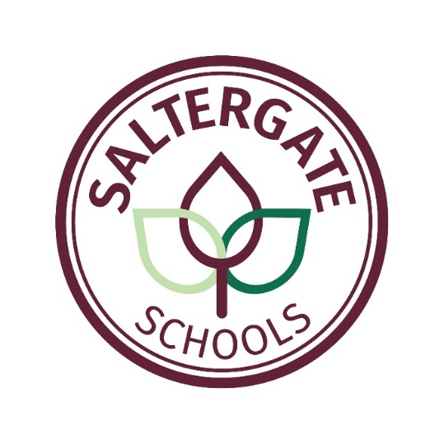

|  |  |  |
| --- | --- | --- |
| Reviewed and Approved by: | Governing Body | |
| Date Adopted: | September 2025 | |
| Signed by: | Chair of Governors  Kirsty Bull | Headteacher  Jo Hall |
| Signed: | Kirsty Bull | Jo Hall |

**DRUGS EDUCATION POLICY**

# RATIONALE

**The development of personal and social skills is crucial to success and fulfilment in adult life and we take the view that it is our responsibility to promote this in a positive and supported way.**

At Saltergate Schools we believe that it is vital that the children grow in self-confidence and are enabled to develop positive self-esteem. We regard these as pre-requisite to being able to make responsible, healthy and well-informed decisions about their lives and how these can impact on others.

We recognise that there are many pressures placed on young people as they grow, and it is our intention that the children will learn to respect themselves and others and move with confidence from childhood, through adolescence to being an adult.

# AIMS

* To provide opportunities for the children to consider what drugs are.
* For the children to be aware that there are legal and illegal drugs.
* To build up an awareness of personal safety when medicines are prescribed.
* To support the children in developing personal and social skills enabling them to make informed decisions.
* To encourage the children to adopt a safe and healthy lifestyle.

# GUIDELINES

**In the Early Years Foundation Stage**, it is through the Physical Development Area of Learning that children come to recognise the importance of keeping healthy and learning about those things which contribute to this.

**In Key Stages 1 and 2,** the teaching about drugs is embedded in the Science and PSHE curriculum and the content is age appropriate.

* The children will learn about the role of prescribed medicines and those bought over the counter to help them when they are feeling ill.
* Children will learn that medicines come in different shapes and forms
* They learn that medicines are drugs, but that not all drugs are medicines.
* The children need to know that some people need regular medication to be able to live a normal life and that some drugs can prevent the development of diseases. The staff will be sensitive in their approach as there may be child or a family member who needs such medication.
* Safety issues are discussed – where to keep medicines, following instructions on the label, not to put anything in their mouths or on their skin if they do not know what it is and what to do if they find medicines or drugs etc. The children need to know that all drugs have the potential to cause harm.
* To enable the children to make decisions, some of the teaching will take the form of presenting scenarios and dilemmas. The children consider different courses of action it is possible to take and the impact that these will make. It is important that the children know that they can ask for help and information both now and in the future.

**In both Key Stages**

The children will know that there are rules about children taking medicines in school.

They will also learn

* about making choices that improve their health and well being
* how some diseases spread and can be controlled
* that all household products, including medicines, can be harmful if not used properly
* ways to keep safe and about people who can help them to stay safe
* to consider social and moral dilemmas that they come across in everyday life
* to ask for help.

.

All of the staff recognise that children may be aware of illegal drugs from online sources, conversations with peers and adults and situations in their own lives. Questions will be answered appropriately with regard to age and maturity of the children.

**Role of Parents.**

As part of our partnership with parents, this policy can be accessed on the school website and comments are invited from parents / carers. The policy is also available as a paper copy.